21st Century Lesson Cycle Template

Grade: 7 -9 Subject: Bus dismissal safety
Classes 1-3 Unit: Life Skills
Driving Question:
- Can you exit the building safely from your homeroom?
- Can you walk through the parked buses and get on your bus safely?
- Can you independently and safely leave your homeroom and board your bus?

Outcomes:
- Life skills related - Students will exit the school safely and efficiently and board their bus at bus dismissal.
Expected Time: 3x30 minute classes:

- Class #1: 5 minutes for introduction of need for bus dismissal safety and etiquette and introduction of key words/phrases, 3-5 minutes for video, 20 minutes for simulated practice.
- Class #2: 3-5 minutes for review of key words/phrases, safety and etiquette, 3-5 minutes for video as needed, 20-25 minutes for simulated practice followed by performance-based assessment completed by students and teacher.
- Class #3: 3-5 minutes for review of key words/phrases, safety and etiquette, 3-5 minutes for video as needed, 20-25 minutes to create bus dismissal safety poster. Time also available for additional performance-based assessment completed by students and teacher as needed.

Resources:
- iPad with Piccolage app (graphic organizers) and Airplay from teacher Mac book.
- Video
- Student ipads pre-loaded with various creativity tools.
- Bus dismissal safety checklist.
- Bus dismissal safety representation rubric.

Lesson Procedure |  | 21st century skills
 | Teacher does (I Do):  Class #1:  - Introduce reasons for bus dismissal safety and etiquette (students stay in homerooms until bell sounds, students then exit in an orderly manner, then move through the parked buses to safely board their bus); display using graphic organizers in Tools4Students app, iPad and Airplay.  - Present key words/concepts using Piccolage, iPad and Airplay (left, right, hallway, downstairs, safely, board bus, etc).  - Video for students to watch.  Classes #2 and #3:  - Review graphic organizer with reasons for bus dismissal safety.  - Review key words/concepts in Piccolage.  - Video available for students to watch. | ☐ find, validate  ☒ remember, understand  ☐ collaborate, communicate  ☐ analyze, synthesize  ☐ critical thinking  ☐ evaluate, leverage  ☐ create, publish  ☒ citizenship
 | Individual student work (You Do):  Class #1:  - Students use steps from video and Piccolage to practice proper etiquette and safety to leave their homeroom for bus dismissal.  Class #2:  - Students use steps from video and Piccolage to demonstrate proper etiquette and safety to leave their homeroom for bus dismissal. Complete the performance-based assessment.  Class #3:  - Students will demonstrate their knowledge of proper etiquette and safety to leave their homeroom for bus dismissal and create a poster or other representation to share with the class. | ☐ find, validate  ☒ remember, understand  ☐ collaborate, communicate  ☒ analyze, synthesize  ☒ critical thinking  ☒ evaluate, leverage  ☒ create, publish  ☒ citizenship
 | Group work (We Do):  Class #1:  - 20 minutes for simulated practice.  Class #2:  - 3-5 minutes for review of key words/phrases, safety and etiquette.  - 20-25 minutes for simulated practice followed by performance-based assessment completed by students and teacher.  Class #3:  - 3-5 minutes for review of Piccolage, safety and etiquette. | ☐ find, validate  ☒ remember, understand  ☒ collaborate, communicate  ☒ analyze, synthesize  ☒ critical thinking  ☐ evaluate, leverage  ☐ create, publish  ☒ citizenship
 | Group work (We Share):  Class #3:  - Share student’s representations of bus dismissal safety and etiquette. | ☐ find, validate  ☐ remember, understand  ☐ collaborate, communicate  ☐ analyze, synthesize  ☐ critical thinking  ☐ evaluate, leverage  ☒ create, publish  ☒ citizenship
Lesson Wrap Up:

- Review key words and exiting safety and etiquette to leave their homeroom at bus dismissal.

Differentiation/Modification/Enrichment:

- Time available to complete additional performance-based assessment until satisfactory.
- Video available for review as needed.

Assessment:

- Bus dismissal safety rubric – Demonstrate exiting safety and etiquette to leave their homeroom at bus dismissal.

Teacher Reflection:

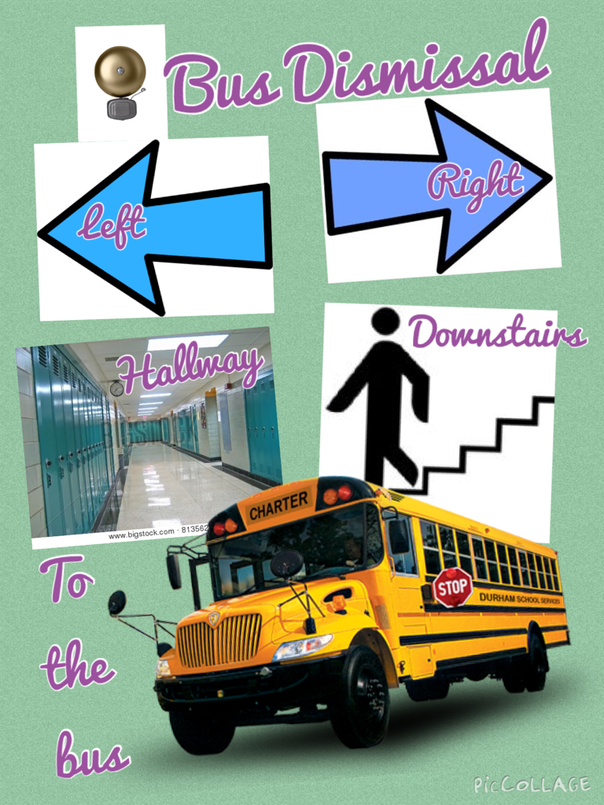

Back

Back

Bus Dismissal Safety Rubric

CRITERIA | C | B | A
Representation shows the exit etiquette from homeroom with clear visuals and directions | Representation clearly shows exit etiquette from homeroom with precise visuals and directions. | Representation somewhat shows exit etiquette from homeroom with precise visuals and directions. | Representation lacks detail in showing exit etiquette from homeroom with precise visuals and directions.
Representation shows the exit etiquette to the bus with clear visuals and directions | Representation clearly shows exit etiquette to the bus with precise visuals and directions. | Representation somewhat shows exit etiquette to the bus with precise visuals and directions. | Demonstration lacks detail in showing the exit etiquette to the bus with precise visuals and directions.
Representation shows the exit safety from homeroom to the bus with clear visuals and directions | Representation clearly shows the exit safety from homeroom to the bus with clear visuals and directions | Representation somewhat shows the exit safety from homeroom to the bus with clear visuals and directions | Demonstration lacks detail in showing the exit safety from homeroom to the bus with clear visuals and directions
FINAL

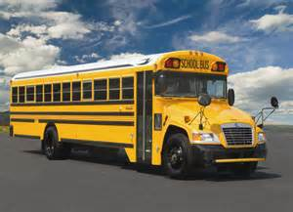

Back

