21st Century Lesson Cycle Template

Grade: 7 -9 Subject: Using Calendar App
Unit: School Skills
Driving Question:
- Can you independently add events to your Calendar app and set alerts?

Outcomes:
- School skills related - Students will add school events, activities, tests and assignments to the calendar app and set alerts for reminders.
Expected Time: 1x30 minute classes:
Resources:
- iPad or iPhone with Calendar app and Airplay.
- Video
- Individual student devices with Calendar app
- Checklist of events to set.

Lesson Procedure |  | 21st century skills
 | Teacher does (I Do):  - Have an alert on my phone’s Calendar app set to go off at the beginning of class.  - Discuss the importance of using an organizational system to keep track of due dates and reminders. Reinforce that using the Reminders app is just one tool to help students get organized.  - Share the importance of having and using the app to remind me, even as an adult, of the tasks and responsibilities that I need to do/complete.  - Show video of how to use Reminders app. | ☐ find, validate  ☐ remember, understand  ☐ collaborate, communicate  ☐ analyze, synthesize  ☐ critical thinking  ☐ evaluate, leverage  ☐ create, publish  ☒ citizenship
 | Group work (We Do):  - As a class, using my iPad and Air Play show students how to change alert sounds and set one to use. This is the fun part of the class…. Making funny noises!  - As a class, add an alert to go off at a specified time.  - As a class, add a fictional event and set the alert to go off.  - Show an adult your alert and then get the Activity Checklist. | ☐ find, validate  ☒ remember, understand  ☒ collaborate, communicate  ☒ analyze, synthesize  ☒ critical thinking  ☐ evaluate, leverage  ☐ create, publish  ☒ citizenship
 | Individual student work (You Do):  - Students use video and previous practice to complete the Activity Checklist. | ☐ find, validate  ☒ remember, understand  ☐ collaborate, communicate  ☐ analyze, synthesize  ☒ critical thinking  ☐ evaluate, leverage  ☒ create, publish  ☐ citizenship
 | Class share (We Share):  - Students share their completed events on their activity calendar using AirPlay. | ☐ find, validate  ☒ remember, understand  ☒ collaborate, communicate  ☒ analyze, synthesize  ☒ critical thinking  ☐ evaluate, leverage  ☐ create, publish  ☒ citizenship
Lesson Wrap Up:

- Review the importance of using an organizational system to keep track of due dates and reminders. Reinforce that using the Reminders app is just one tool to help students get organized.

Differentiation/Modification/Enrichment:

- Limit or increase the number of events to schedule.
- Limit or increase the need to change alarms by event and just use one alert sound.
- Add photos and/or emojis to various events.

Assessment:

- Demonstrate ability to use Reminders app to set alerts for various events. Use Activity Checklist to share with an adult when completed. Share your completed calendar to the class via AirPlay.

Teacher Reflection:

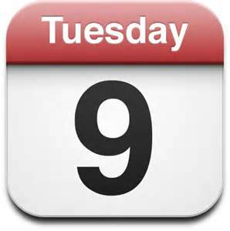
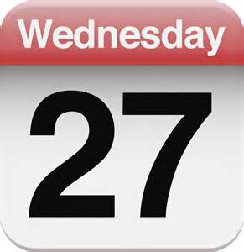
Calendar Crazy!!

Use your Reminders app to set alerts for the

following events and activities.

DATE | TITLE | LOCATION | STARTS | ENDS | REPEAT? | ALERT | 2ND ALERT
Sept. 17 | First Dance | NGRHS | 7:00 pm | 10:00 pm |  | 1 day
Sept. 30 | Monthly science assignment |  | 9:00 am |  |  | 2 days | 1 day
Oct. 6 | Math test |  |  |  |  | 2 days | 1 day
Oct. 12 | Thanksgiving – no school |  | All day |  |  | 1 day
Oct 21 | Basketball practice | NGRHS | 4:30 pm | 6:00 pm | Every Thursday | 1 day | 1 hour

When you have finished, show your completed calendar to an adult. We will AirPlay your work.

