21st Century Lesson Cycle Template

Grade: 7 -9 Subject: Responding to a fire drill
Class #1 of 3 Unit: Life Skills

Driving Question:
- Can you independently respond appropriately to a fire alarm in the school?
- Do you know where to meet your class once you have exited the building after a fire alarm?

Outcomes:
- Life skills related - Students will exit the school efficiently using the proper escape routes in the event of a fire drill.
- Students will line up on the soccer field with their classmates following a fire drill.
Expected Time: 3x30 minute classes:

- Class #1: 3-5 minute group discussion on fire safety and fire drills, 3-5 minutes for video, 20-25 minutes for practice exiting various grade 7 classrooms based on exit map for each room.

Resources:
- Fire exit maps from English, math & social studies, science and French classrooms.
- iPad with Tools4Students app and Airplay from teacher Mac book.
- Video

Lesson Procedure |  | 21st century skills
 | Teacher does (I Do):  - Present key words/concepts on white board (left, right, hallway, downstairs, soccer field, line up).  - Present video for students to watch.  - Model checking the exit maps in each of the above classrooms upon entry. | ☐ find, validate  ☒ remember, understand  ☐ collaborate, communicate  ☐ analyze, synthesize  ☐ critical thinking  ☐ evaluate, leverage  ☐ create, publish  ☒ citizenship
 | Group work (We Do):  - Class discussion on fire drills in their previous elementary schools. Venn diagram using Tools4Students app on iPad streamed to LCD via Airplay showing similarities and differences between their elementary schools and NGRHS. | ☐ find, validate  ☒ remember, understand  ☒ collaborate, communicate  ☒ analyze, synthesize  ☒ critical thinking  ☒ evaluate, leverage  ☐ create, publish  ☒ citizenship
 | Individual student work (You Do):  - Students use steps from video and key words to demonstrate proper response to a fire drill from the Learning Centre. | ☐ find, validate  ☒ remember, understand  ☐ collaborate, communicate  ☐ analyze, synthesize  ☒ critical thinking  ☐ evaluate, leverage  ☐ create, publish  ☐ citizenship
 | Group work (We Do):  - Use steps from video to respond as a class from other 4 classrooms. Individual checklists for pre-assessment. | ☐ find, validate  ☒ remember, understand  ☒ collaborate, communicate  ☒ analyze, synthesize  ☒ critical thinking  ☒ evaluate, leverage  ☐ create, publish  ☒ citizenship
Lesson Wrap Up:

- Review key words and exiting procedures from each of the classrooms used today.
- Importance of having escape routes from different classrooms.
- Importance of having alternate escape routes from each classroom.

Differentiation/Modification/Enrichment:

- Routes highlighted on mobile copies for students to follow while exiting individual classrooms.

Assessment:

- Fire escape checklist – performance based pre-assessment

Teacher Reflection:

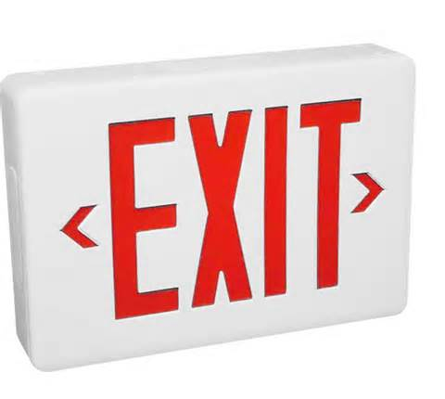

Safely uses escape route from the Learning Centre.

Safely uses alternate escape route from the Learning Centre.

*******************************************************************************************

Safely uses escape route from Mr Bruhm’s room.

Safely uses alternate escape route from Mr. Bruhm’s room.

*******************************************************************************************

Safely uses escape route from Mrs. Wentzell’s room.

Safely uses alternate escape route from Mrs. Wentzell’s rooom.

*******************************************************************************************

Safely uses escape route from Ms. DeLong’s room.

Safely uses alternate escape route from Ms. DeLong’s room.

*******************************************************************************************

Safely uses escape route from the Mr. O’Hearon’s room.

Safely uses alternate escape route from Mr. O’Hearon’s room.

Back

