21st Century Lesson Cycle Template

Grade: 6-7 Subject: Following a schedule

Unit: School Skills
Driving Question:
- Can you follow the 8-day schedule to determine which classes you have and when?
- Do you know where to go for each class?
- Who will your teacher be for each class?

Curriculum Outcomes:
- School skills related
Expected Time: 1-30 minute class

- 10 mins instructional time
- 3-5 mins for video
- 15 mins for practice and review
- 5 mins for quiz

Resources:
- Class schedule specific to each student.
- Map of the school, access to white board
- Instructional videoSticky notes
- Key words on white board (days, period, cycle, long period)

Lesson Procedure |  | 21st century skills
 | Teacher does (I Do):  - Introduce the key words/concepts (day, period, cycle, first, second, third, fourth, fifth, lunch, long period).  - Present key words/concepts on white board  - Present video for students to watch | ☐ find, validate  ☒ remember, understand  ☐ collaborate, communicate  ☐ analyze, synthesize  ☐ critical thinking  ☐ evaluate, leverage  ☐ create, publish  ☐ citizenship
 | Individual student work (You Do):  - Use steps from video and key words from the white board to practice determining which classes the students would have during different days and periods on the cycle.  - Model questions to understand how to use a schedule. Give template of questions so students will understand what type of practice they will be participating in. | ☐ find, validate  ☒ remember, understand  ☐ collaborate, communicate  ☒ analyze, synthesize  ☒ critical thinking  ☐ evaluate, leverage  ☐ create, publish  ☒ citizenship
 | Group work (We Do):  - Use steps from video to practice finding and asking their peer to find different classes throughout the cycle.  - Use template as needed. For example: What class do you have day 4, period 3? When do you have art classes?  - Share and switch schedules. | ☐ find, validate  ☒ remember, understand  ☒ collaborate, communicate  ☒ analyze, synthesize  ☒ critical thinking  ☒ evaluate, leverage  ☐ create, publish  ☒ citizenship
 | Class share (We Share):  - Mini class quiz. | ☐ find, validate  ☒ remember, understand  ☒ collaborate, communicate  ☒ analyze, synthesize  ☒ critical thinking  ☒ evaluate, leverage  ☐ create, publish  ☒ citizenship
Lesson Wrap Up:

- Review of key words

Differentiation/Modification/Enrichment:

- Sticky notes with key words on them: (days, period, cycle, long period)
- Several copies of individual student schedules.
- Answers to specific questions on the template.

Assessment:

- Demonstrate how to follow two different schedules to an adult in the room as an Exit Pass.
- Students can leave the learning centre with an adult and demonstrate they can follow the schedule by going to the classroom as requested by the adult (following questions from the template).

Teacher Reflection:

QUESTION TEMPLATE FOR
“FOLLOWING A SCHEDULE”

- What do you have first period on day _____?

- What do you have second period on day _____?

- What do you have for the long period on day _____?

- What do you have after lunch on day _____?

- What do you have last class on day _____?

- On day _____ (1, 2, 3, 4, 5, 6, 7, 8), what do you have ______ period?

(1st, 2nd, 3rd, 4th, 5th)

- What class do you have day _____, period _____?

- When do you have (subject)?

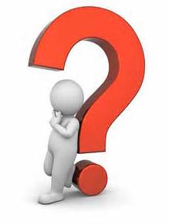
(English, math, science, social studies, healthy living, French, music, art and Phys. Ed)

- What time is _____ period?

(1st, 2nd, 3rd, 4th, 5th)

- When is lunch?

Back
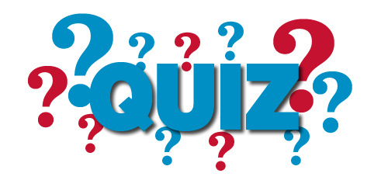

True or False?

- __________ You have math day 1, period 2.
- __________ You have science day 3, period 1.
- __________ French is day 5, period 5.
- __________ Lunch is from 12:15-1:00 everyday.
- __________ You have English everyday.

Fill in the blanks

- You have science day _____ period 4.
- You have math day 1 period _____.
- Lunch starts at __________ everyday.
- We go back to homeroom at the end of the day at __________.
- Your two Healthy Living classes are day _____ period _____ and day 6 period _____.
- Your PE classes are: day _____, period 2; day 5 period _____ and day _____ period _____.

Back

