21st Century Lesson Cycle Template

Grade: 7-9 Subject: Two-way conversations
5 day lesson play
Unit: Social Thinking
Driving Questions:
- Can you trade interesting information with a peer?
- Can you participate in a two-way conversation?

Outcomes:
- Students will share relevant and interesting information with their peer.
- Students will participate in a 2-way conversation.
Expected Time:

5x30 mins sessions

Resources:
PEERS Manual
Making Friends app (videos)
White board and markers or computer connected to LCD on a word processor
iPad connected to Airplay and LCD.
Power Point
Personal devices

Lesson Procedure |  | 21st century skills
 | Teacher does (I Do)  Individual student work (You Do)  Group work (We Do)  Class share (We Share)  - Follow the information and activities in Two-Way Conversation power point.  - Each succeeding day, we will follow the lesson plan as presented in the Power Point. | ☒ find, validate  ☒ remember, understand  ☒ collaborate, communicate  ☒ analyze, synthesize  ☒ critical thinking  ☒ evaluate, leverage  ☒ create, publish  ☒ citizenship
Lesson Wrap Up:
- Daily review of content learned, discussed and shared.
- Review key phrases of trading information and having 2-way conversations.
- Complete Exit Passes

Assessment:
- Daily Exit Passes x5
- Wordle – word splash of personal interests

Teen’s Topics of Conversations on Wordle

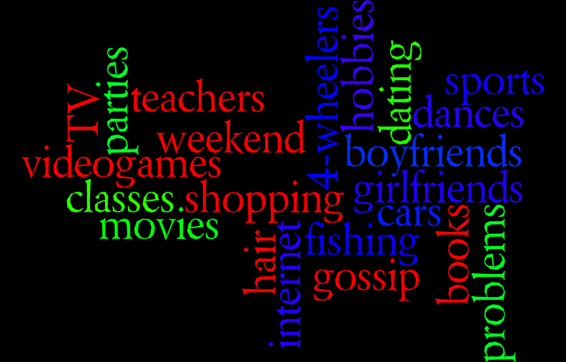

Back

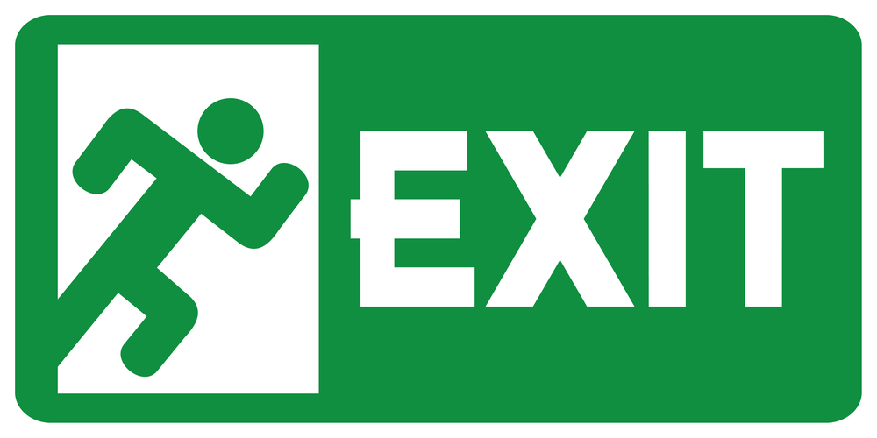
Pass

Write or draw a description of 3 things you learned or practiced in class today.

Back

