21st Century Lesson Cycle Template

Grade: 6-7 Subject: Learning to use a combination lock

Unit: Life Skills
Driving Question:
- Can you independently open and close a 1-2-3 digit combination lock?

Outcomes:
- Life skills related skill- Students will be able to unlock a combination lock with 3 digits.
Expected Time:
- 1x30 minute class: Approx: 15 mins + 15 mins of practice time

Resources:
Several combination locks with different combinations; 1-2-3 digit combinations.
Video
Exit Pass

Lesson Procedure |  | 21st century skills
 | Teacher does (I Do):  - Model using a combination lock - opening and closing the lock.  - Present key words/concepts on white board (left, right, zero, past the zero).  - Present video for students to watch. | ☐ find, validate  ☒ remember, understand  ☐ collaborate, communicate  ☐ analyze, synthesize  ☐ critical thinking  ☐ evaluate, leverage  ☐ create, publish  ☒ citizenship
 | Individual student work (You Do):  - Use steps from video and key words from the white board to practice opening and closing 1-digit, 2-digit and 3-digit combination locks. | ☐ find, validate  ☒ remember, understand  ☐ collaborate, communicate  ☐ analyze, synthesize  ☒ critical thinking  ☐ evaluate, leverage  ☐ create, publish  ☐ citizenship
 | Group work (We Do):  - Use steps from video to practice opening and closing combination lock with a peer. Share and switch locks. | ☐ find, validate  ☒ remember, understand  ☒ collaborate, communicate  ☒ analyze, synthesize  ☒ critical thinking  ☐ evaluate, leverage  ☐ create, publish  ☒ citizenship
 | Class share (We Share):  - Use steps from video and key words from white board to practice opening and closing combination locks with other peers in the class. | ☐ find, validate  ☒ remember, understand  ☒ collaborate, communicate  ☒ analyze, synthesize  ☒ critical thinking  ☐ evaluate, leverage  ☐ create, publish  ☒ citizenship
Lesson Wrap Up:

- Review the key words and concepts of using a combination lock (left, right, zero, past the zero).

Differentiation/Modification/Enrichment:

- Sticky notes with key words on them: left, right, the numbers in the combination, etc.
- Combination locks with one and two digit combinations, rather than three digit.

Assessment:

- Demonstrate two different combinations to an adult in the room as an Exit Pass.
- Students can leave the learning centre and practice putting their lock on the locker and using the combination to unlock the lock.

Teacher Reflection:

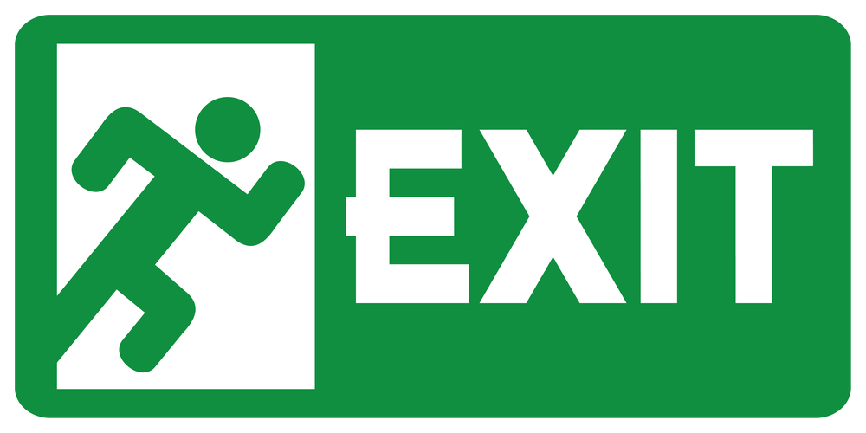
Pass

Directions:

- Write in the locker combination of the lock.
- The adult will check the box when you have demonstrated you can open the lock.

Lock #1:

Combination ___________________________

Lock #2:

Combination ____________________________

Back

