21st Century Lesson Cycle Template

Grade: 6-7 Subject: Opening Your Locker

Unit: School Skills
Driving Question:
- Can you open your combination lock when it’s on your locker?

Curriculum Outcomes:
- School skills related
Expected Time: 1-30 minute session

- 5 mins for video
- 5-10 mins for review and instructional time
- 5-10 mins for practice and mastery
- Can return to homeroom after completing Exit Pass

Resources:
- Instructional video
- Student’s own combination lock
- Student lockers
Exit Pass

Lesson Procedure |  | 21st century skills
 | Teacher does (I Do):  - Review the key words/concepts from “Opening a Lock”. (left, right, zero, past the zero).  - Present key words/concepts on white board  - Present video for students to watch | ☐ find, validate  ☒ remember, understand  ☐ collaborate, communicate  ☐ analyze, synthesize  ☐ critical thinking  ☐ evaluate, leverage  ☐ create, publish  ☒ citizenship
 | Individual student work (You Do):  - Use steps from video and key words to practice opening their locks on their lockers. | ☐ find, validate  ☒ remember, understand  ☐ collaborate, communicate  ☐ analyze, synthesize  ☒ critical thinking  ☐ evaluate, leverage  ☐ create, publish  ☐ citizenship
 | Group work (We Do):  - If they are able to open their own lockers, use steps from video and key words to practice opening a peer’s locker. | ☐ find, validate  ☒ remember, understand  ☐ collaborate, communicate  ☐ analyze, synthesize  ☒ critical thinking  ☐ evaluate, leverage  ☐ create, publish  ☒ citizenship
Lesson Wrap Up:

- Complete Exit Pass and return to homeroom.

Differentiation/Modification/Enrichment:

- Sticky notes with key words on them: left, right, the numbers in the combination, etc.
- Combination locks with one digit combination, rather than three digit combination.
- Practice opening their peer’s lockers.

Assessment:

- Demonstrate the can open and close their locker as an Exit Pass.

Teacher Reflection:

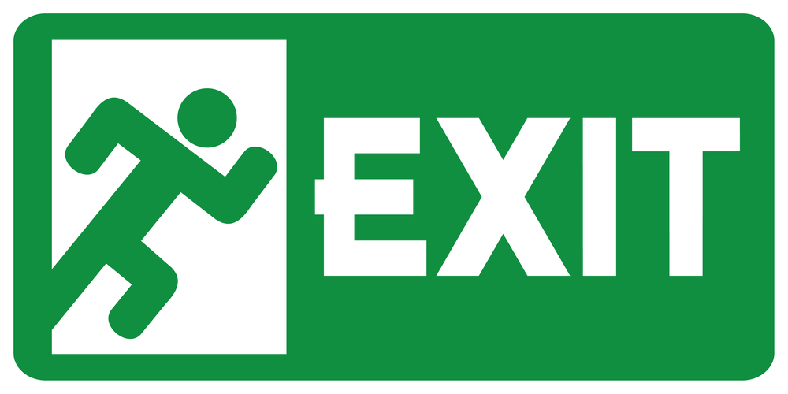
Pass

Directions:

- Demonstrate that you can open your combination lock alone.
- Demonstrate that you can open your combination lock while on your locker.

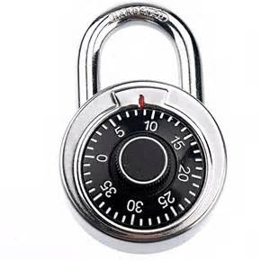
Open your lock:

Open your locker

Lock your locker

Back

