21st Century Lesson Cycle Template

Grades: 7-9 Subject: Trading Information

Day 4 Unit: Social Thinking
Driving Questions:
- Can you trade interesting information with a peer?
- Can you find common interests with a peer?

Outcomes:
- Students will share relevant and interesting information with their peer.
- Students will find and share common interests.
- Students will follow class-designed rules for trading information with a peer.
Expected Time:

1x30 mins sessions

Resources:
PEERS Manual
White board and markers or computer connected to LCD on a word processor
Individual iPads
Air Server
Jeopardy Sheet

Lesson Procedure |  | 21st century skills
 | Teacher does (I Do):  - Review their Do’s and Don’ts of Trading Information checklists on their iPads or view class list.  - Review Perspective Taking Questions.  - Write Jeopardy Topics on the white board or via LCD. | ☐ find, validate  ☒ remember, understand  ☐ collaborate, communicate  ☐ analyze, synthesize  ☐ critical thinking  ☐ evaluate, leverage  ☐ create, publish  ☒ citizenship
 | Individual student work (You Do):  - Students practice trading information about the Jeopardy Topics with all group members. | ☐ find, validate  ☒ remember, understand  ☒ collaborate, communicate  ☐ analyze, synthesize  ☐ critical thinking  ☐ evaluate, leverage  ☐ create, publish  ☒ citizenship
 | Group work (We Do):  - Play Teen Jeopardy. (Rules in PEERS Manual page 40-41). | ☐ find, validate  ☒ remember, understand  ☒ collaborate, communicate  ☐ analyze, synthesize  ☒ critical thinking  ☐ evaluate, leverage  ☐ create, publish  ☒ citizenship
 | Class share (We Share):  - Class share Exit Pass. | ☐ find, validate  ☒ remember, understand  ☒ collaborate, communicate  ☒ analyze, synthesize  ☒ critical thinking  ☒ evaluate, leverage  ☒ create, publish  ☒ citizenship
Lesson Wrap Up:
- Class share Exit Pass

Differentiation/Modification/Enrichment:

Assessment:
- none

Teacher Reflection:

Perspective
Taking
Questions:

- What was that like for you?

- What did you think of me?

- Would you want to talk to me again?

Back
Do’s Checklist

- Do ask the other person questions about themselves.
- Do answer your own questions.
- Do find common interests.
- Do share the conversation.

Don’ts Checklist

- Don’t be an interviewer.
- Don’t be a conversation hog.
- Don’t get too personal too fast.
Back
Pass

Did you like Teen Jeopardy? Why or why not?

What did you do well? (The Do’s)

What do you need to work on ? (The Don’ts)

Back

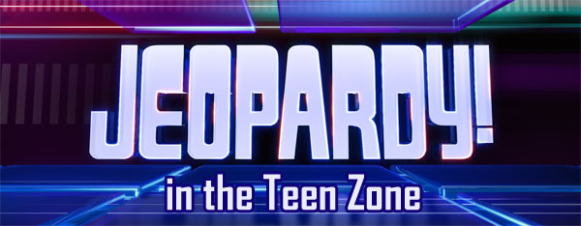

“Music to your Ears”  The answer is:________________’s favourite band. (name)  The question is:  What is __________________________?  (favourite band) | “TGIF”  The answer is:______________’s favourite  weekend activity. (name)  The question is:  What is __________________________?  (favourite weekend activity)
“Sports and Leisure”  The answer is:______________’s favourite  sport or activity. (name)  The question is:  What is _________________________?  (favourite sport or activity) | “Game Time”  The answer is:____________________’s  favourite game. (name)  The question is:  What is _________________________?  (favourite game)
“Let’s go to the Movies”  The answer is:_________________’s favourite movie. (name)  The question is:  What is __________________________?  (favourite movie) | “TV Time”  The answer is:______________’s favourite TV show. (name)  The question is:  What is _________________________?  (favourite TV show)
“Bestseller List”  The answer is:____________’s favourite book. (name)  The question is:  What is __________________________?  (favourite book | “In your Eyes”  The answer is:____________’s eye colour  (name)  The question is:  What is _________________________?  (eye colour)
Back

